

D. Y. Patil Agricultural and Technical University
Talsande

PROJECT REPORT
on
Visualization Tool for Electric Vehicle Charge and Range Analysis

Department
Master Of Computer Applications
(MCA Sandwich Sem II)
2026-2027

Submitted By
1.Samruddhi Yadav
2. Shraddha Mali
3.Rakshita Amange
4.Anuradha Asule

Index

Sr No | Title | Page No
1 | INTRODUCTION
2 | IDEATION PHASE
3 | REQUIREMENT ANALYSIS
4 | PROJECT DESIGN
5 | PROJECT PLANNING & SCHEDULING
6 | FUNCTIONAL and PERFORMANCE TESTING
7 | RESULT
8 | ADVANTAGES and DISADVANTAGES
9 | CONCLUSION
10 | FUTURE SCOPE
11 | RESOURCES

1. INTRODUCTION

1.1 Project Overview
Electric Vehicles (EVs) are transforming the automotive industry with a strong focus on sustainability, efficiency, and smart technology. This project provides a unified data visualization tool for EV buyers, analysts, and decision-makers. Using Tableau, we created an interactive dashboard that integrates multiple datasets — including vehicle specifications, pricing, and charging infrastructure — to support insights and informed decisions. The dashboard allows users to compare EV models, analyze charging station distribution, and filter results by multiple parameters, making data exploration easy and insightful.

1.2 Purpose
The primary purpose of this project is to develop a visual analytics dashboard that helps understand EV trends, brand comparisons, and infrastructure availability across India and globally. The project simplifies EV decision-making by consolidating four different datasets into a single visualization tool using Tableau. This supports a wide range of users, from consumers evaluating EVs to analysts and policymakers planning for electric mobility expansion.

2. IDEATION PHASE

2.1 Problem Statement
How might we help EV buyers and stakeholders explore electric vehicle specifications, pricing, efficiency, and charging infrastructure in India and globally through interactive dashboards and storytelling?
Consumers and decision-makers often struggle to access consolidated EV-related information due to the scattered nature of online resources. This leads to inefficient planning, comparison difficulties, and a lack of clarity. Our project aims to solve this by integrating multiple EV datasets into a single, visually-driven analysis tool using Tableau.

2.2 Empathy Map Canvas
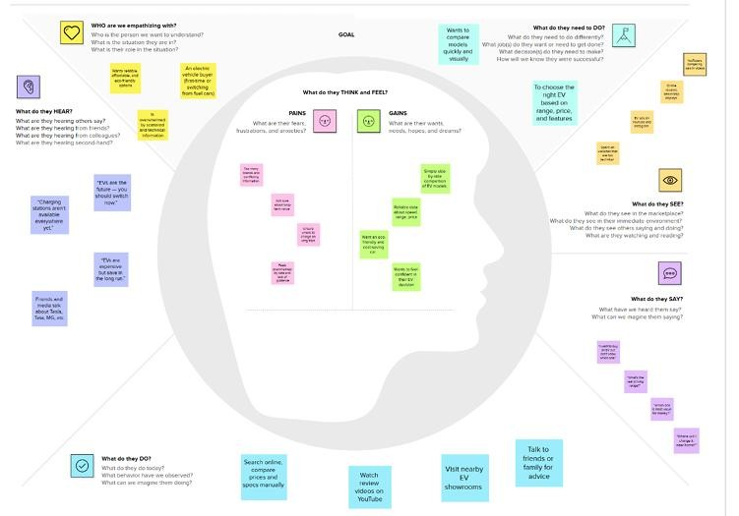
This empathy map helped us better understand user expectations and frustrations. It guided the design of filters, summaries, and visual maps in our dashboard.

2.3 Brainstorming (Idea Generation & Prioritization) We generated and prioritized the following ideas:
Ideas Generated | Priority
Charging station map by state/region | High
Price vs Range comparison across models | High
Top 10 efficient EV brands visualized | High
Filters for powertrain type and body style | Medium
Summary cards comparing India and global EV trends | Medium
Dashboard KPI cards (Top Speed, Price, Efficiency) | High
Story view to guide non-technical users through insights | High

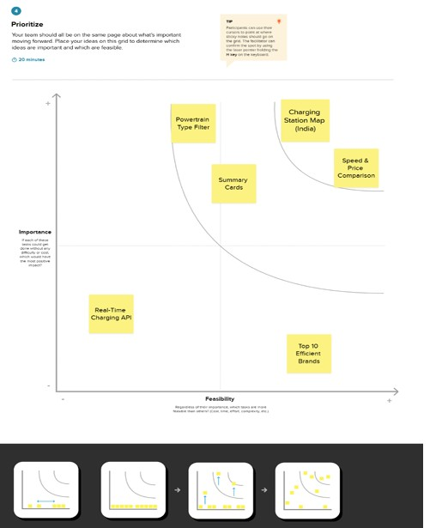

3. REQUIREMENT ANALYSIS
Stage | User Action | Experience | Opportunity
Awareness | Searches for EV models and charging station info | Overwhelmed by multiple sources | Provide a centralized dashboard with all info in one place
Consideration | Compares speed, price, and efficiency of EV brands | Lacks clarity and reliable data | Visualize comparisons with filters and charts
Decision  Making | Shortlists cars based on performance and affordability | Struggles to prioritize | Add summary cards, KPI metrics, and ranking-based visuals
Post-Purchase | Looks for nearby charging infrastructure | Unsure of charging availability | Provide state-wise charging map and chargertype filters

3.2 Solution Requirement
Requirement Type | Description
Functional Requirements | - Import EV datasets into a database  - Create dashboards & story in Tableau
Data Requirements | - 4 datasets: EV specs, price, brand, and charging stations
Visualization Requirements | - Bar charts, maps, KPI cards, filters, and summary cards
User Requirements | - Dashboard should be user-friendly, visual, and filterable
Technical Requirements | - Use MySQL for data storage  - Use Tableau Desktop & Public for visualization

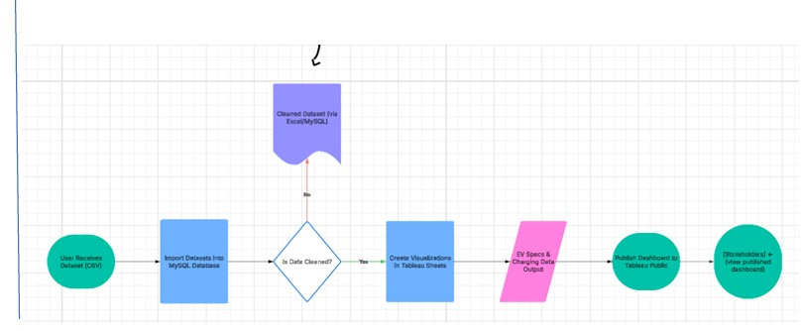

3.4 Technology Stack:
The Deliverable shall include the architectural diagram as below and the information as per the table1 & table 2
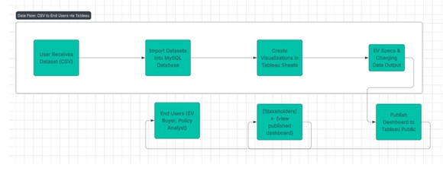
Category | Tool/Technology Used
Data Source | CSV Files
Database | MySQL
Data Cleaning/Storage | SQL Queries (within MySQL)
Visualization | Tableau Desktop, Tableau Public
Documentation | MS Word, Google Docs
Project Sharing | GitHub, Tableau Public

4. PROJECT DESIGN

Problem | Proposed Solution
EV data is scattered across multiple sources, making comparisons difficult for consumers. | Centralized Tableau dashboard integrating multiple datasets for easy exploration.
No visual representation of available EV charging infrastructure across Indian states. | Interactive map and region-wise charts showing charger types and distribution.
Lack of user-friendly filtering (e.g., by price, brand, powertrain) for EV evaluation. | Dashboard filters for brand, powertrain type, body style, and top speed for decisionmaking.

This alignment between real-world user pain points and targeted dashboard features ensures usability and impact.

4.2 Proposed Solution
The proposed solution is an interactive EV data visualization tool built using Tableau, supported by a MySQL backend for structured data storage.
Key features include:
- Charts comparing price, top speed, and efficiency of EV models.
- Filters for brand, powertrain type, and body style.
- Charging station data shown using regional maps and bar charts.
- Summary cards and KPI metrics to simplify decision-making.
- A narrative story view that guides users step-by-step through EV insights.

4.3 Solution Architecture
You can represent this visually in your diagram, or describe it as below:
- Data Collection – Four CSV files collected covering EV specs, prices, and charging stations.
- Data Storage – Datasets imported into MySQL, with cleaned and structured tables.
- Data Connection – Tableau Desktop connected to the MySQL database using server credentials.
- Visualization Layer – Dashboards and stories built in Tableau with filters, maps, charts, and cards.
- Publishing – Final visualizations published on Tableau Public for public access and sharing.
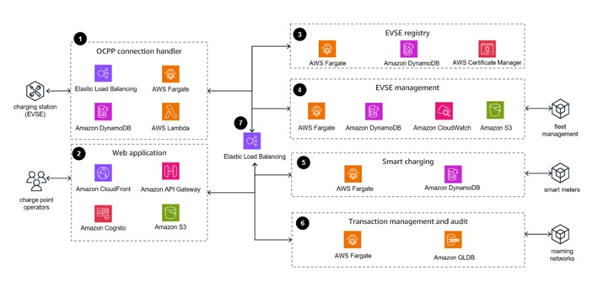

5. PROJECT PLANNING & SCHEDULING

5.1 Project Planning
We adopted an agile approach with two focused sprints to manage development and visualization work efficiently.

Sprint Planning Table
Sprint | Functional  Requirement  (Epic) | User  Story No. | User Story / Task | Story  Points | Priority | Team  Members
Sprint-  1 | Data Connection | USN-1 | Import all EV datasets into MySQL and verify schema | 2 | High | Gotloori  Balaji
 | Data  Visualization  (Cars) | USN-2 | Create comparison views for EVs by price, speed, and efficiency | 3 | High
 | Data  Visualization  (Charging) | USN-3 | Build visualizations for charging stations by region and type | 2 | High
Sprint-  2 | Filtering  Features | USN-4 | Implement filters for body style, | 2 | Medium
 |  |  | powertrain, and brand
 | Summary Cards | USN-5 | Create summary  KPIs for India vs  Global EV data | 2 | Medium
 | Dashboard &  Story Integration | USN-6 | Combine sheets into interactive dashboard and design the story | 3 | High
 | Publish  Dashboard | USN-7 | Publish dashboard and story on Tableau  Public | 1 | High

Sprint Tracker
Sprint | Total  Story  Points | Duration | Sprint  Start Date | Sprint  End Date | Story Points  Completed | Sprint  Release Date
Sprint-  1 | 7 | 5 Days | 25 June  2025 | 29 June  2025 | 7 | 29 June 2025
Sprint-  2 | 8 | 6 Days | 30 June  2025 | 5 July  2025 | 8 (planned) | 5 July 2025  (planned)

Velocity
Velocity = Story Points Completed ÷ Duration
Velocity = 7 ÷ 5 = 1.4 story points/day
This helped us plan Sprint-2 more accurately by allocating 8 points over 6 days.

6. FUNCTIONAL AND PERFORMANCE TESTING

6.1 Performance Testing
The dashboard was evaluated based on data rendering, filters, calculated fields, visual components, and story navigation. Below is a summary of key testing outcomes:

Model Performance Testing Table
Sr No | Parameter | Details
1 | Data Rendered | Four datasets used:  - EVIndia.csv  - ElectricCarData_Clean.csv  - Cheapestelectriccars-EVDatabase.csv  - electric_vehicle_charging_station_list.csv
2 | Data Preprocessing | Cleaned using SQL:  - Null value removal  - Column renaming  - Duplicate elimination  - Data typed and formatted in MySQL
3 | Utilization of Filters | Filters included:  - Brand  - Body Style  - Powertrain Type  - Region  - Charger Type
4 | Calculation Fields Used | Created fields for:  - Efficiency (Range ÷ Battery Capacity)  - Price/Range Ratio  - Speed Rank  - Total Models by Brand
5 | Dashboard Design | Dashboard has over 6 sheets with:  - Maps  - Bar charts  - KPI summary cards  - Interactive filters
6 | Story Design | Story consists of 6 scenes:  - Navigation across sheets  - User-guided exploration  - Brand & region comparison pages

7. RESULTS

EV Charging Stations by Region and Type (India)
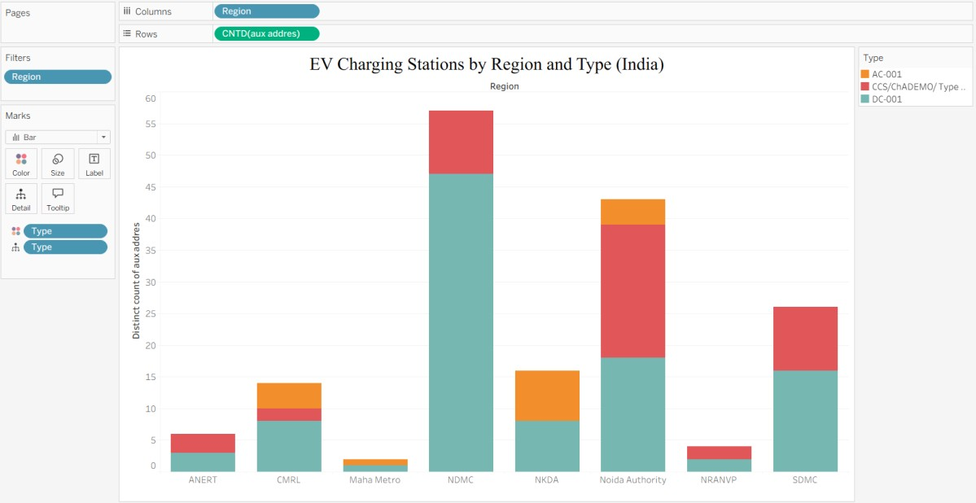

EV Charging Stations Map (India)
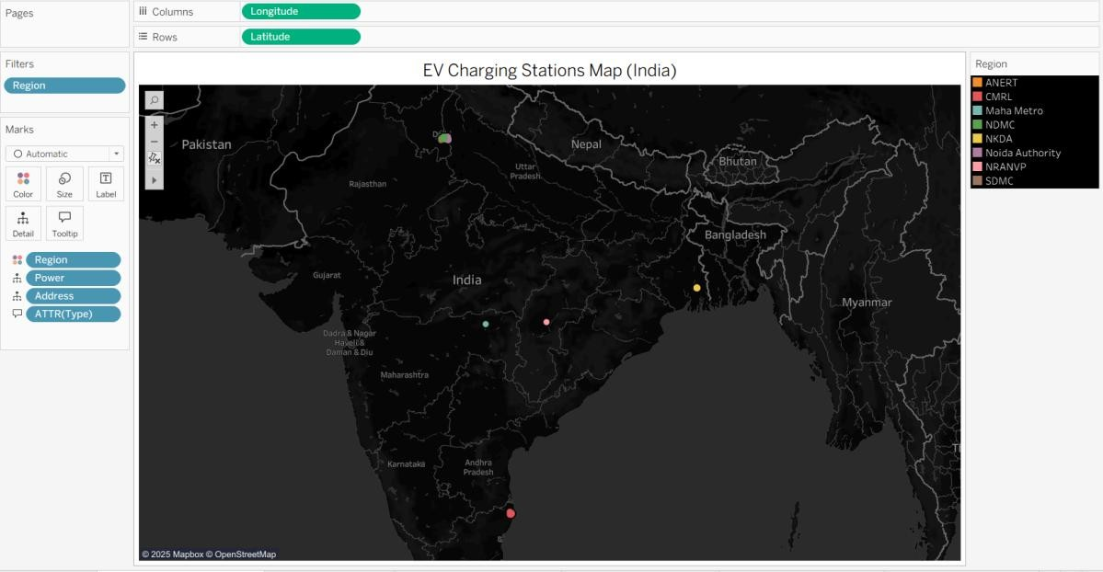

Different EV Cars in India
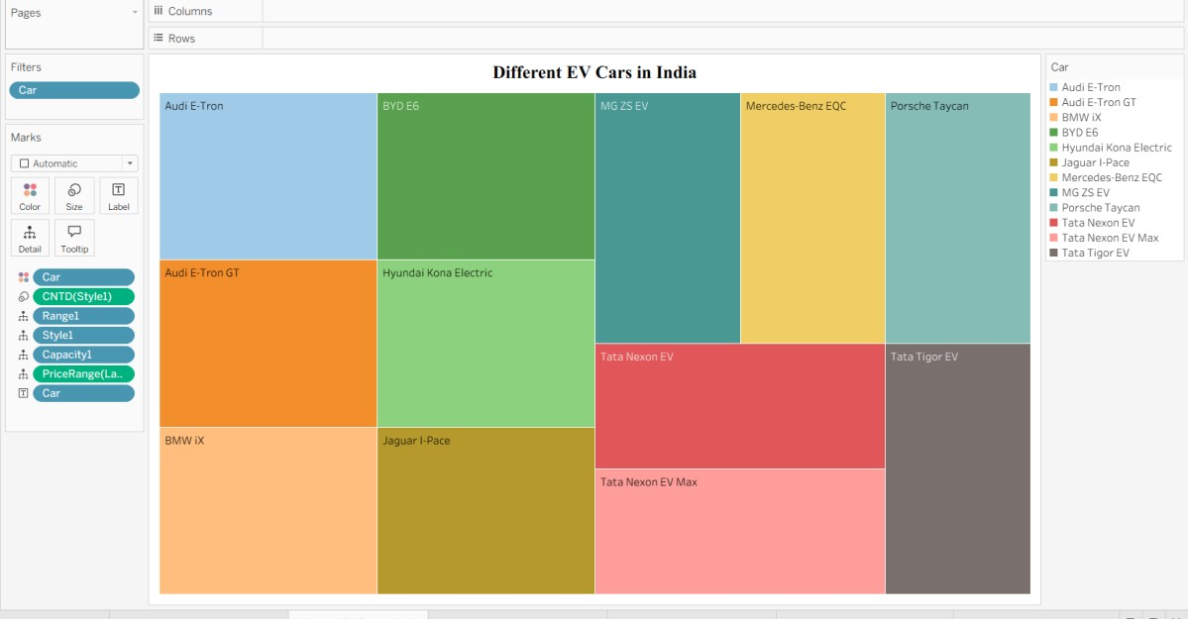

Top Speed for Different Brands (India)
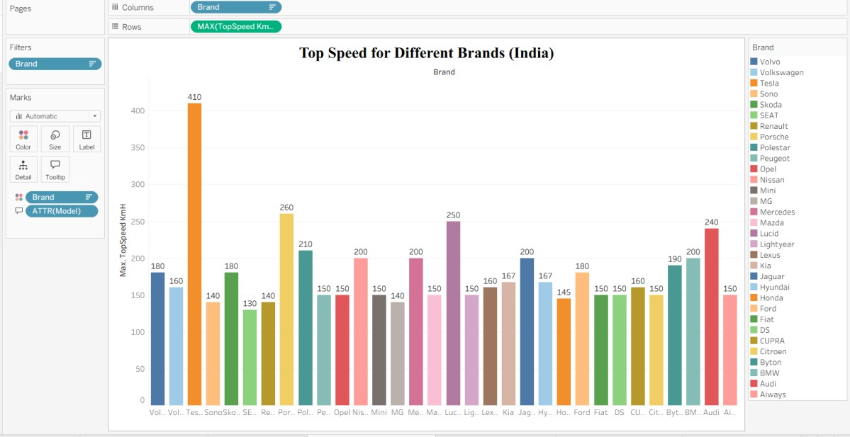

Price for Different Cars in India
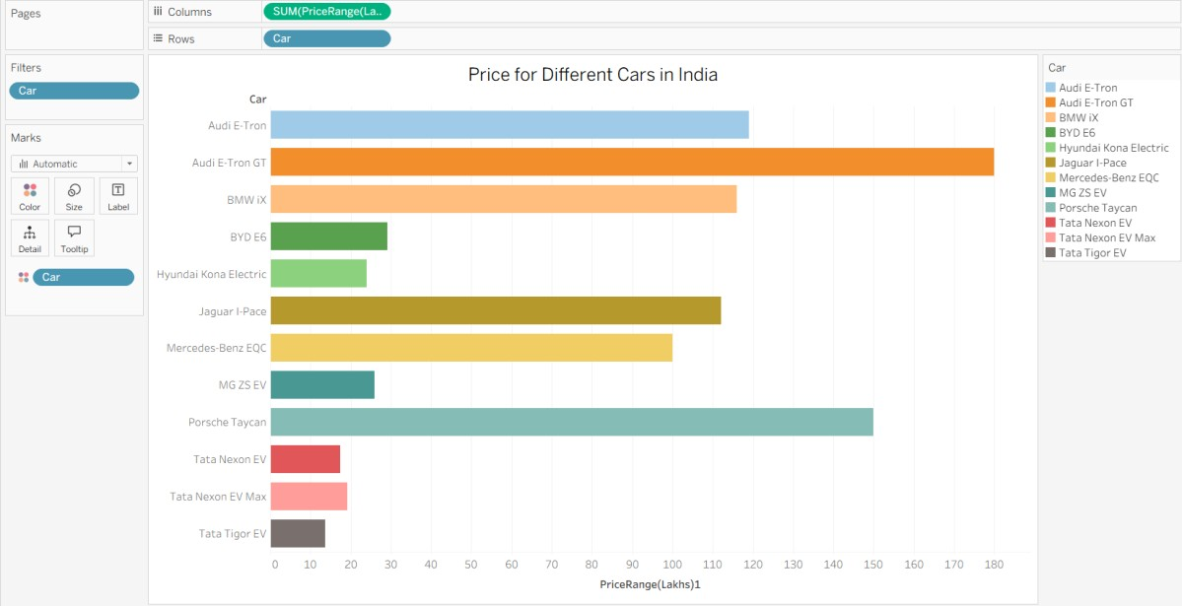

Top 10 Most Efficient EV Brands
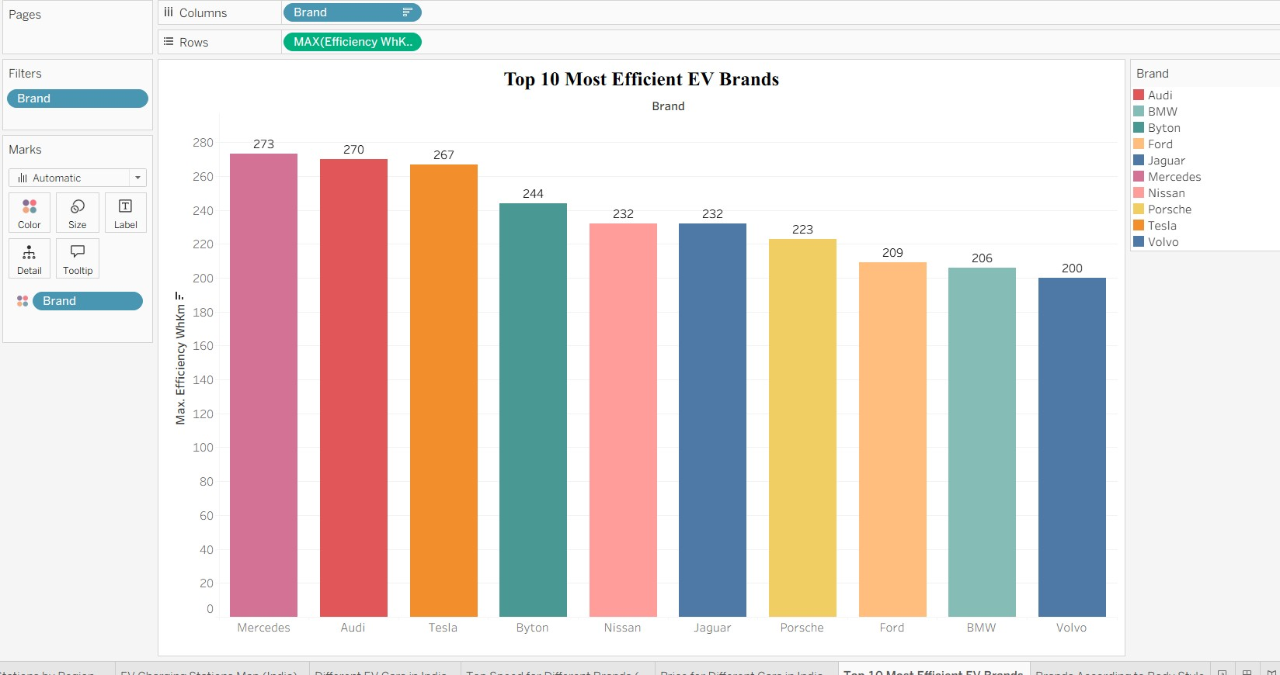

Brands According to Body Style
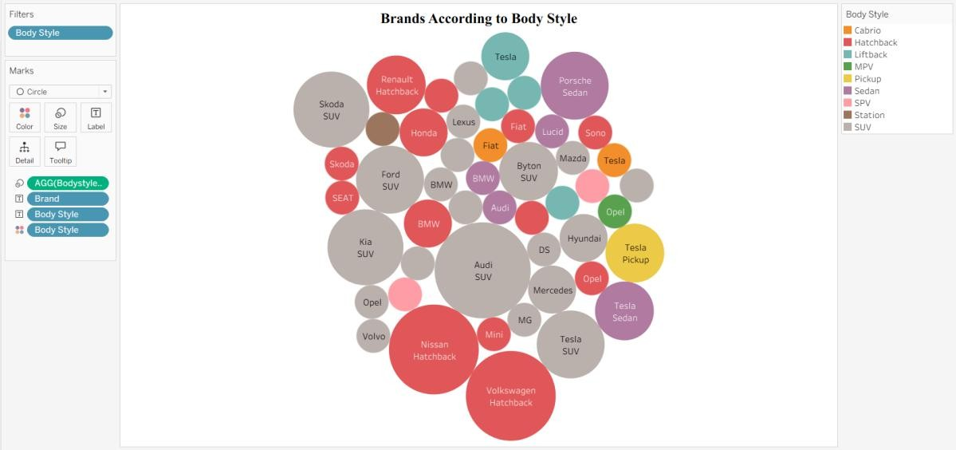

No of models by each brand
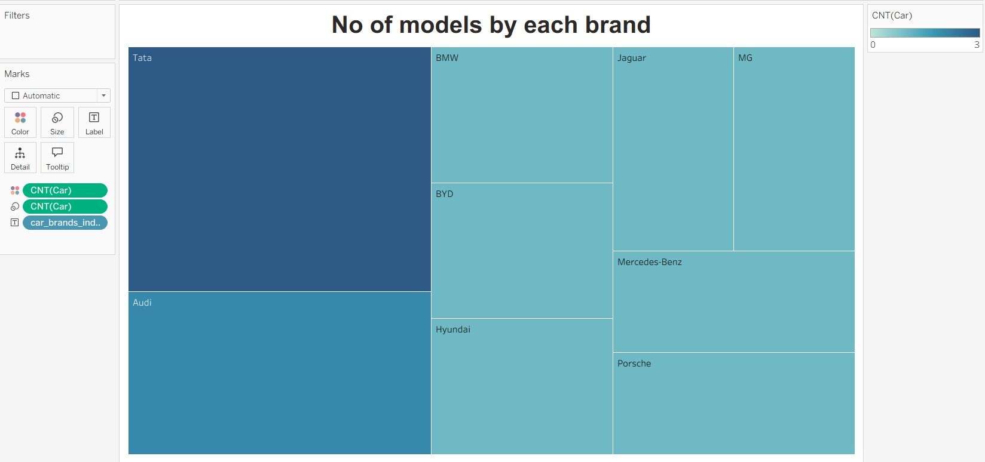

Brand filtered by PowerTrain type
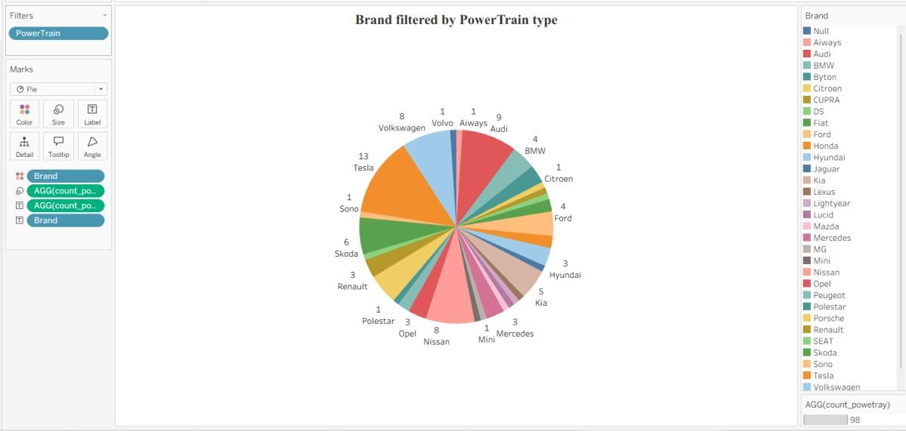

EV Charge & Range Analysis Dashboard
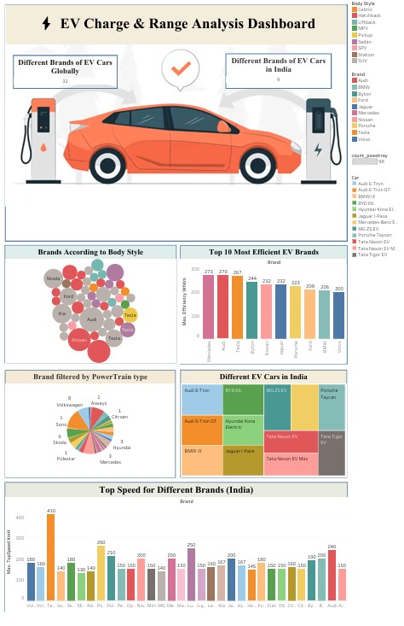

Story of Electric Cars In India
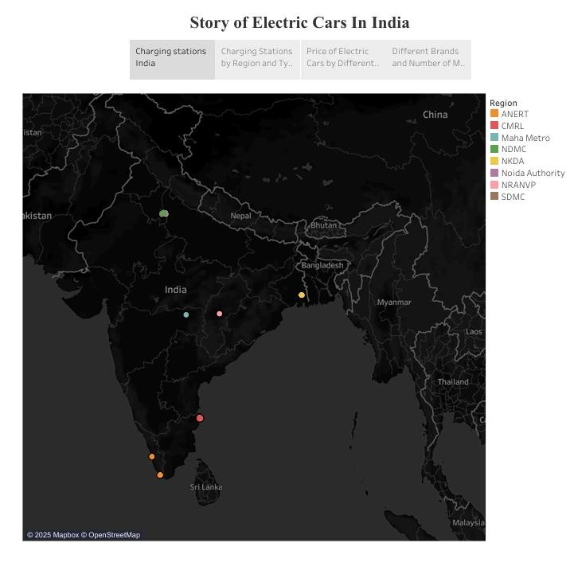

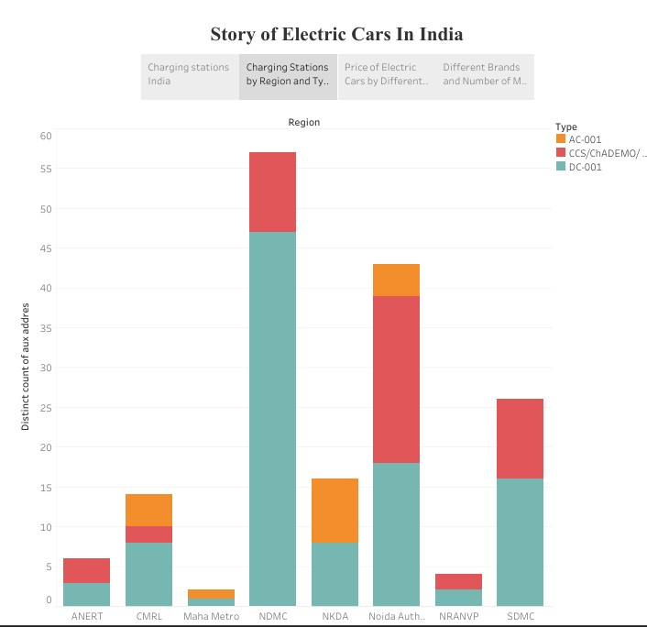
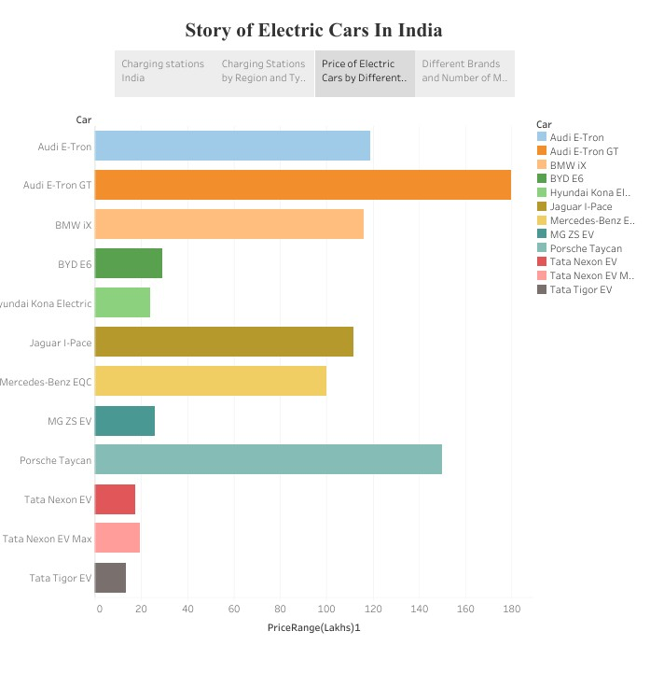
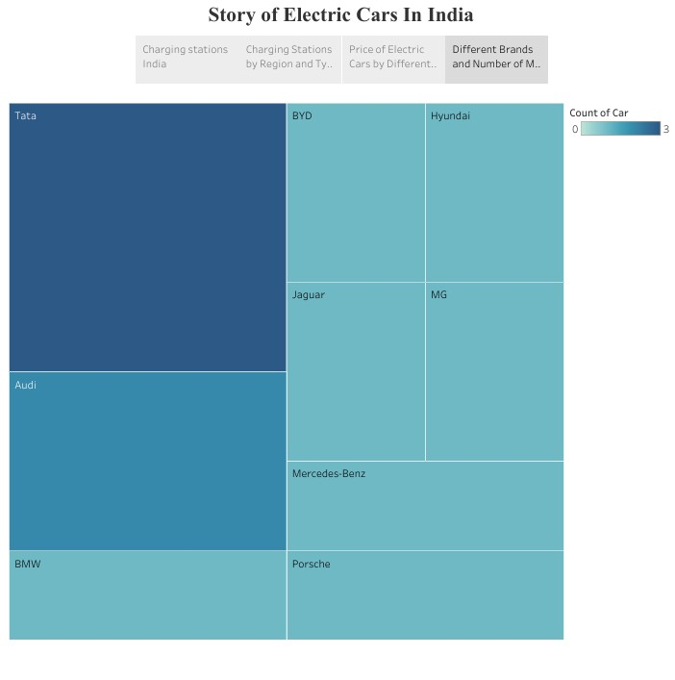

8. ADVANTAGES & DISADVANTAGES

Advantages
- Centralized Visualization
Combines multiple EV datasets into one dashboard, reducing the need to browse multiple sources.
- User-Friendly Interface
Interactive filters, maps, and summary cards make the dashboard easy to use for both technical and non-technical users.
- Real-Time Analysis Capabilities
Connected to a live database (MySQL), allowing future scalability with real-time updates.
- Insightful Visuals
Enables clear comparisons between EV models, charging infrastructure, price, and performance metrics.
- Storytelling Approach
The story feature in Tableau allows users to navigate insights in a guided, narrativedriven format.

Disadvantages
- Static Dataset
As the data is not auto-updated, new EV entries or changes require manual refresh and reimport.
- Limited Regional Coverage
Charging station data is currently India-focused; international charger info was not available.
- Requires Internet Access
Tableau Public dashboards need internet connectivity to be accessed and shared.
- Dependent on Dataset Quality
Accuracy is limited to the reliability and completeness of the source datasets.

9. CONCLUSION
The project successfully achieved its objective of creating a unified data visualization tool for electric vehicles using Tableau. By integrating and analyzing multiple datasets related to EV specifications, prices, efficiency, and charging infrastructure, we developed an interactive dashboard and a guided story view that simplifies complex data into actionable insights.
This solution helps consumers make informed decisions when selecting EVs, and also supports policymakers and analysts in understanding EV adoption trends and infrastructure needs. The visual format enhances clarity and accessibility, making the data usable for a wide range of stakeholders.

10. FUTURE SCOPE

1. Real-Time Data Integration
The current dashboard uses static datasets. Future enhancements could involve
connecting APIs or live data streams for real-time EV pricing, specifications, and charging station availability.

2. Expansion to Global Charging Infrastructure
Currently focused on Indian charging station data, future versions can include global charger locations and filters by country or continent.

3. User Login and Personalization
Integrating user login functionality with personalized dashboards can help users track preferred brands or nearby chargers based on geolocation.

4. Advanced Predictive Analytics
Future iterations can incorporate machine learning models to recommend EVs based on usage patterns or predict EV adoption trends region-wise.

5. Mobile-Responsive Dashboard
Optimizing the Tableau dashboard for mobile users would increase accessibility, especially for on-the-go EV buyers or travelers.

11. RESOURCES

- GitHub Repository :
https://shraddhamali04-tech.github.io/Visualization-Tool-for-Electric-Vehicle-Charge-and-Range-Analysis/
- Tableau Workbook Files:
1.Dashboard:
https://public.tableau.com/views/ElectricCarsAnalyticsDashboard_17728587954940/Dashboard3?:language=en-US&:sid=&:redirect=auth&:display_count=n&:origin=viz_share_link
2.Story: https://public.tableau.com/views/StoryofElectricCarsinindia/StoryofElectriccarsinindia?:language=en-US&:sid=&:redirect=auth&:display_count=n&:origin=viz_share_link
- Dataset Links : https://drive.google.com/drive/folders/1Rkzdks6Us1Uq2SRB4nxMAb83jN5bpHll

Demo video link :
https://drive.google.com/file/d/1KyeRcN9OD7OhDY6o9m6o83a_UKd_TFZ5/view?usp=drivesdk

